**Greatest Finding!!!Scientists Discover Planets Better Than Earth**

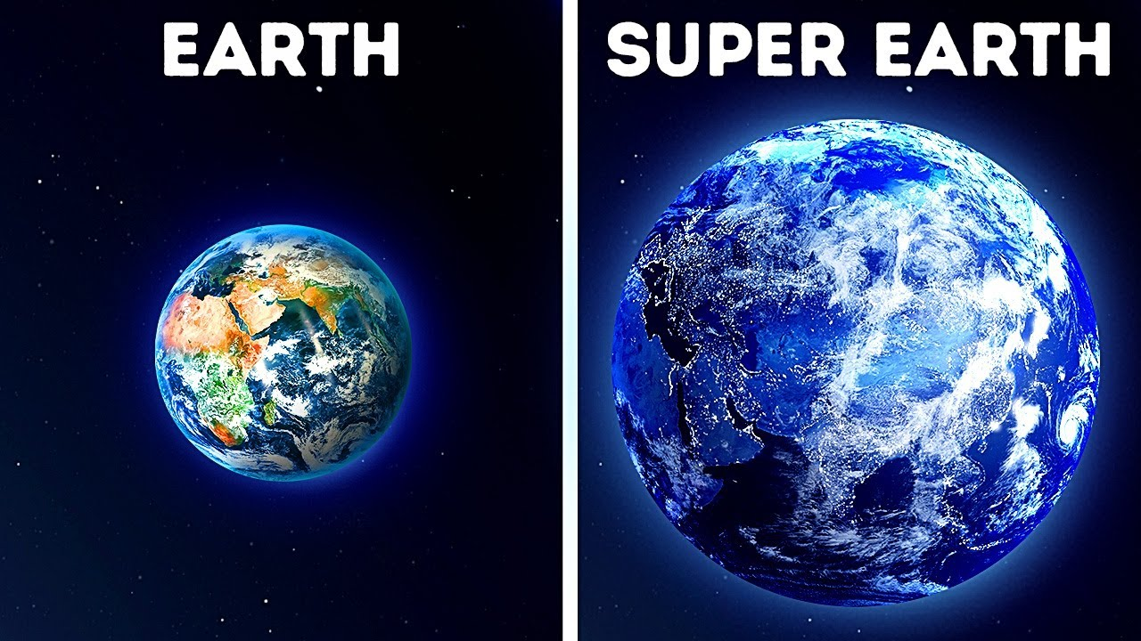

The curiosity to know the unknown is a unique characteristic of human nature. One special quality of human nature is our insatiable curiosity for the unknown. Humanity has always been captivated by the idea of exploring the vastness of the cosmos. We have long believed that if we visit another planet in the cosmos without making the necessary preparations, we will instantly perish due to the planet's strong gravity, intense heat, intense pressure, and unfavorable atmosphere. But there are some planets in the universe where visiting can even give a feeling that you have got superpowers. Recently scientists have discovered a lot of habitable planets which are better than Earth by all means. On these planets, life can evolve better than Earth. In astronomy, finding exoplanets—worlds outside of our solar system—has been a tremendous accomplishment. Among these findings, astronomers have come across planets with possibly more livable circumstances than Earth. This article explores the fascinating field of exoplanets, their discovery, and the exciting possibility of discovering habitable worlds outside of our own.

Astronomers have been trying to discover planets around far-off stars for eras. The finding of the first verified exoplanets revolving around a pulsar followed by a sun-like star in the 1990s marks a significant advancement in space exploration. Technological developments in the following decades triggered the finding of thousands of exoplanets, especially with telescopes and detecting technologies.

The search for habitable planets requires finding celestial bodies that have the necessary elements for supporting life as we know it. The area in which a planet can keep liquid water on its surface is referred to as the "habitable zone" surrounding a star. The size, temperature, and other properties of the star affect this zone. But habitability is more than just the existence of water. Examining several elements of a planet's potential livability is necessary to explore worlds that are more livable than Earth. The planet's size, structure, atmosphere, surface conditions, and liquid water level are some of these variables, together with the kind and stability of the parent star. Higher degrees of habitability have been assigned to planetary systems with stable orbits, protective atmospheres, and comfortable temperatures.

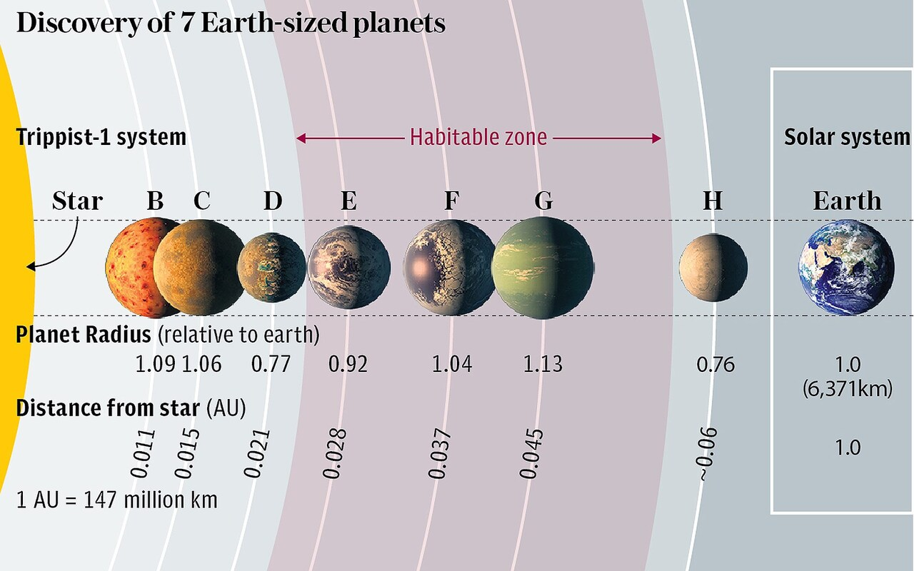

we all know Earth as the only planet in the entire universe -where from simple life forms to complex life forms, all living organisms who are capable of living in extreme environments have been evolved and living. so many people think that Earth is the unique planet where life is possible. but there are a lot of researchers who say that there might be some planets where the environment is more favorable for life. but as we are living on Earth, many scientists are wasting their time to find the mirror of Earth, not to find superior planets to Earth, which is wrong. For this reason, on 5th October 2020, the astrobiologist of Washington State University and Technical University of Berlin, Dirk Schulze Makuch, started a new mission with his team. During this mission, they have targeted planets that are better than Earth in every way. even they succeed. they have got 24 super habitable planets. They followed a different approach to this mission. they made a criteria list for the planets. if a planet does not follow the criteria, it will not be a superhabitable planet. We all know, that every life needs some important factors to survive. suitable temperature, atmosphere, water, and land surface area are a must for life to survive. keeping this in mind, they made some criteria where the first one was the age of the host star. generally, when an exoplanet is explored, scientists focus on the yellow dwarf stars, in other words, stars-like sun. but in the mission of Dirk Schulze Makuch, they targeted orange dwarf stars, which are cooler, dimmer, and less massive. The main reason behind this was the lifespan of the stars. all yellow dwarf stars have a lifespan of around 10 billion years, whereas the orange dwarf stars have a 20 to 50 billion years lifespan which is double. That means if any life evolves in that planetary system, it can be evolved two to three times more than Earth, potentially. older stars are not always better.  older planets' interior geothermal energy decreases with time and loses magnetic field. Anyway, the second criterion is water. when a planetary system is found, the first step should be to measure the distance of the planet from the host star. we can know about the habitable zone and the water percentage of the planet from this. the third one was the size and mass of the planet. According to researchers, the size and the mass of the planet help to evolve life. their reason was very simple which was the more the surface would be there, the more the habitable area would be. the more the mass, the more the gravity will be and if the gravity is greater, the atmosphere will be more stable, potential, and thicker. but there is another condition. The mass of the planet should be at most one and a half or two times that of Earth so that the planet's interior can be heated for a long period, and this hot interior helps the core to be molted, and for this, the protective magnetic field will be active for a long time around that planet which will enhance the chance of life rising or evolving. the next important criterion is temperature. if the temperature of a planet is high, indirectly the pressure will also be high and no life can survive in extreme temperatures. so scientists generally target that planets have temperatures five degrees more or less than the average temperature of Earth. there is also a reason behind it. if we consider the tropical region temperature of Earth, the microbe living there can survive in that highest extreme temperature.

Though scientists have had success in exploring 24 exoplanets, many researches are being organized every day. Among those planets, scientists have got two superhabitable planets whose surface, temperature, and atmosphere are much better than Earth's. those two planets are KOI 5715.01 and KOI 5554.01. according to scientists, these two planets have every possible factor that is required for life to evolve. in short, both of the planets are perfect for the evolution of life. The first planet is KOI5715.01, a planet where the temperature is 2.4 degrees Celsius lower than Earth. The mass of this planet is 7 times more than Earth and its size is 8 times more than Earth. that shows the surface area of land is more than the earth. gravity is also more than earth, because of mass. for these reasons, the atmosphere of this planet is very much stable. if we think about water sources, considering the distance between the host star and that planet, scientists have assumed that it has huge water sources which is again great news.

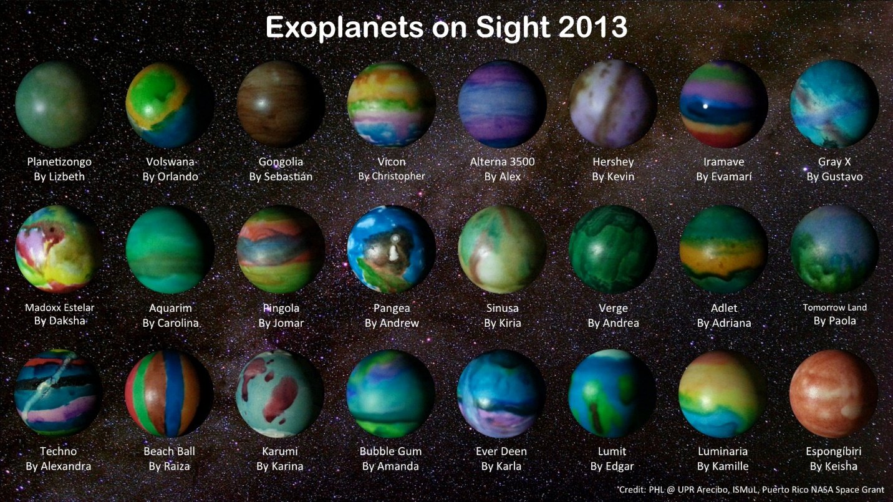

After that, we can see KOI 5554.01 which has a surface temperature of around 27 degrees Celsius which is perfect for the human body to survive. in fact, for the tectonic plate movement of this planet, the nitrogen cycle is going on continuously. we know the nitrogen cycle is essential for Earth, because, by biochemical process, nitrogen converts into multiple chemical forms such as amino acids, proteins, and even DNA which indirectly help us to clean up the environment. The more nitrogen there will be, the more rapidly the ecosystem will evolve, and also atmosphere will be clean. but as these planets were invented recently, scientists do not have that much detailed information. scientists have started research about those planets with the help of the James Webb space telescope.

 Apart from these two planets, some planets are also more habitable than Earth. first, we can look to LHS 1140 b, a very self-contradicting planet. This planet was discovered on 20th April 2017, by transit method of the MEarth Project. MEarth Project is a robotic laboratory, which observes the brightness of Red Dwarf stars. the main goal is to find a transitioning planet, which means that planets pass in front of Red Dwarf stars. As Red Dwarf stars are small, if any planet passes in front of Red Dwarf stars, they cover a larger portion of that planet. By this method, this planet was discovered. after discovery, when scientists studied the surface of this planet, they found that the iron-nickel core of this planet occupies 75% of the landmass in the form of lava. it is a matter of shock that, though the landmass is of lava, scientists have got 4% water under the core. according to them, there are heavy quantity of water under the complete land mass. from this, a lot of astronomers have assumed that there could even be an underground water world. Not just that, for the massiveness of this planet, the atmosphere of the planet has maintained a good balance with the greenhouse effect.

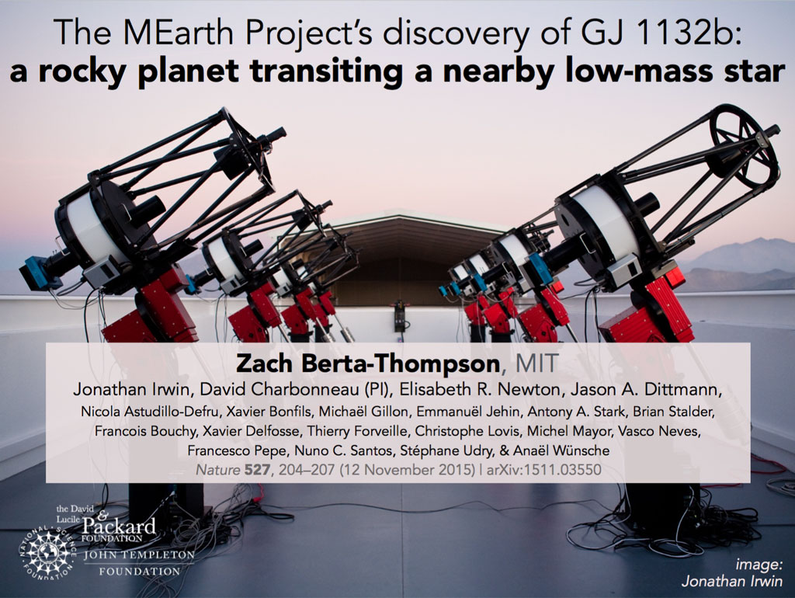

the next planet seems so habitable that scientists have already sent a lot of messages to investigate the extraterrestrial life of that planet. That planet is Luyten B. On 17th March 2017, this planet was discovered with the help of the radial velocity method. Basically, what happens in the radial velocity method is that the position of one star relative to another star is observed. if the position of the star is continuously moving back or forth, that means that there exists any massive planet on that system, which is exerting gravitational influences on that star. So, when the planet was observed, while studying the position of this planet, it was noticed that water content is present in very large quantities on this planet. Essential materials for any life like amino acids and hydrocarbons are also present in large quantities there. So, the planets seem to be perfect. some scientists have also assumed that the reason behind the perfection can be an advanced civilization. this is why, in October 2017 and 2018, extraterrestrial intelligence and METI organization sent different messages to this planet. Among them, one message was a short musical composition and another one was a scientific tutorial about our location in the universe.

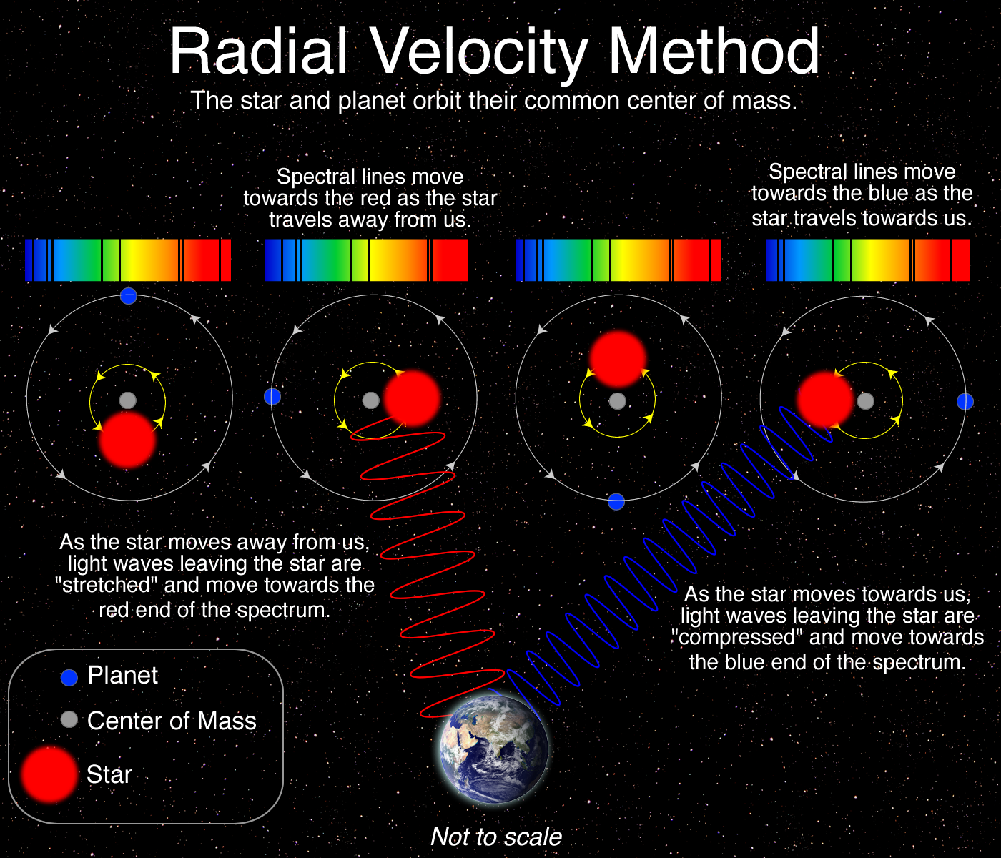

One of the most amazing finds is the approximately 40 light-year-distance TRAPPIST-1 system. This ultra-cool dwarf star is orbited by seven Earth-sized planets, three of which are in the habitable zone. This system generated enthusiasm since it offered a fascinating chance to investigate possibly habitable exoplanets in more detail.

Proxima Centauri b, an exoplanet around Proxima Centauri, the star closest to the Sun, is another noteworthy finding. Because of its closeness to Earth, this rocky planet in the habitable zone has drawn interest and created opportunities for further expeditions and investigations.

When looking for exoplanets, scientists also utilize gravitational microlensing. Exoplanet identification and characterization are formed by the advantages and disadvantages of each approach. Technological developments promise to entirely change our understanding of exoplanets, particularly with the development of advanced observatories like the James Webb Space Telescope. The goal of upcoming missions like the European Space Agency's PLATO (Planetary Transits and Oscillations of Stars) mission is to find and study exoplanets that seem similar to Earth.

There are several obstacles in the way of finding habitable exoplanets, ranging from technological limitations to ethical issues. Deep social and philosophical issues are raised by concerns about planetary preservation, contamination dangers, and the moral consequences of discovering extraterrestrial life.

The finding of planets that may be more livable than Earth represents a critical turning point in humanity's exploration of the universe. These findings not only increase our understanding of science but also spark our curiosity regarding the potential possibility of life outside of our solar system. The hunt for habitable exoplanets is an example of how scientific discovery, technological advancement, and human curiosity are working together. This quest has captured our imagination and continues to inspire us to explore the universe.